EE 432
RF Engineering for Telecommunications

Lab #6
Impulse Response and Multipath

Name: Mohammad Chahardori (Student ID: 11632753)
Partner: Richard Osorio

Due Date: 10/31/2020

Description of the Experiment
Purpose:
In this lab we are going to experiment, analyze and understand the effect of multipath in Wireless communication channel. We are supposed to observe the impulse response of a multi-path environment and the effect of multi path in the received signal in wireless communication then we want to see the relation between the impulse response and the frequency response of the channel due to multipath existence in real radio propagation environment. we will also analyze and observe the relation between the mean delay derived from impulse response and the coherence bandwidth in the cannel behavior in frequency domain.
Procedure:
To do this experiment we have used a network analyzer which is calibrated and set for a frequency range of 700 to 1000MHz. This frequency range includes the mobile 3G and 4G standard, so I expect to have proper behavior of mobile antennas in this range. By connecting two mobile antennas to port1 and port2 of the network analyzer we can send and receive the signal and we can observe the S21 which is the transfer function of the wireless environment between two antennas in frequency domain. We also capture the time domain impulse response of the channel using the network analyzer. There are 401 points in each domain. The time domain spans 200 ns, so the time step is 0.5 ns/sample. The frequency domain spans 300 MHz, so the frequency step is 0.75 MHz/sample.
To observe and analyze the effect of multipath in wireless communication environment we performed the experiment in three different levels and steps. In the first step we put the antennas close to each other, in this case they mostly measure the antenna loss (gain) and the channel behavior in close distance when we have line of sight. In this case we also expect to see one big peak in impulse response due to short direct path. The channel frequency response also should include few peak or deep and has somewhat flat response in several portion of the frequency range. In the second step we put the antenna a little far from each other where we have still line of sight but we should see more than one local peak in impulse response as the effect of multi-pass because of the obstacle and different material that reflected the signal. In the third step which is the last step we put the antenna for from each other in a position where we don't have any line of sight and we receive the signal just due to the reflection from different barriers and reflectors in the environments. in this case we expect to see several local peaks in the impulse response and sharp falls and rises in frequency. For each steps we want to calculate the coherence band width based on the parameters <t> , <t2> and sigma calculated from impulse response using a Matlab code and we want to compare this coherence bandwidth with the observable band width from frequency domain response.
Data Analysis:
The impulse response and the frequency response of the channel for the three different parts of this experiment corresponding to three different distances between antennas have been provided for us. We have used these data in a Matlab code attached to this report to calculate and find the time variance of impulse response as a random variable function and to calculate the coherence bandwidth and plot the impulse response and frequency response of the channel in the three different scenarios.
- Close distance:
Using the MATLAB code and the provided data correspond to close antenna position the impulse response and the frequency response of the channel are plotted in figure 1 and 2.

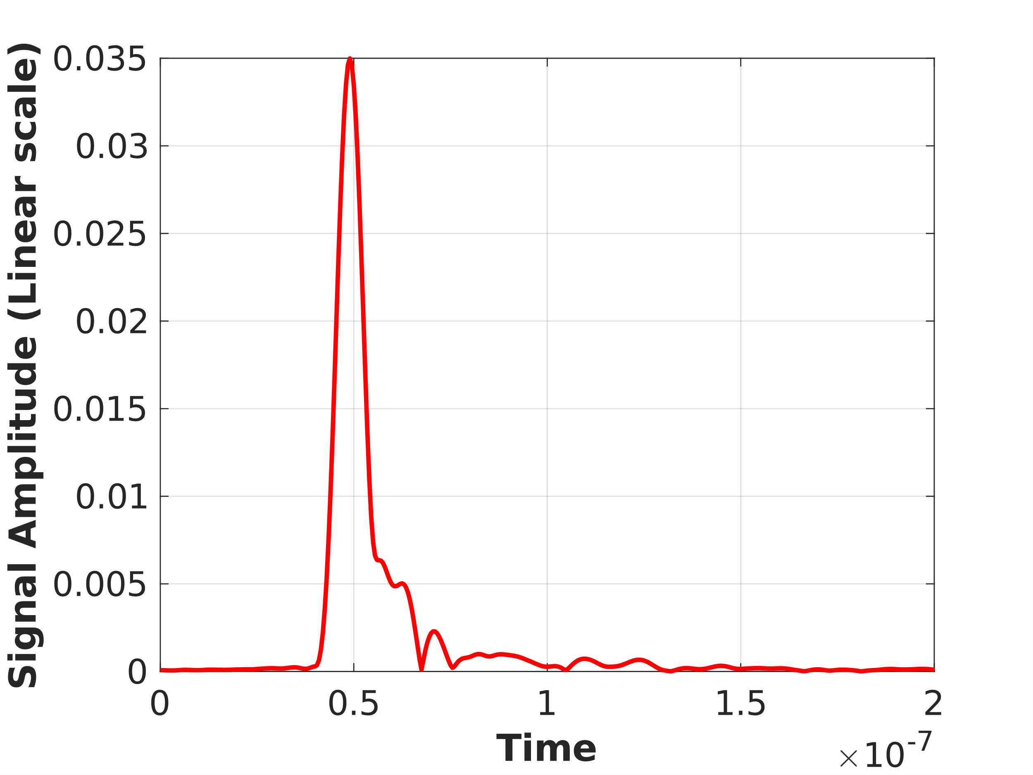
Figure 1: Impulse response of the channel for close distance

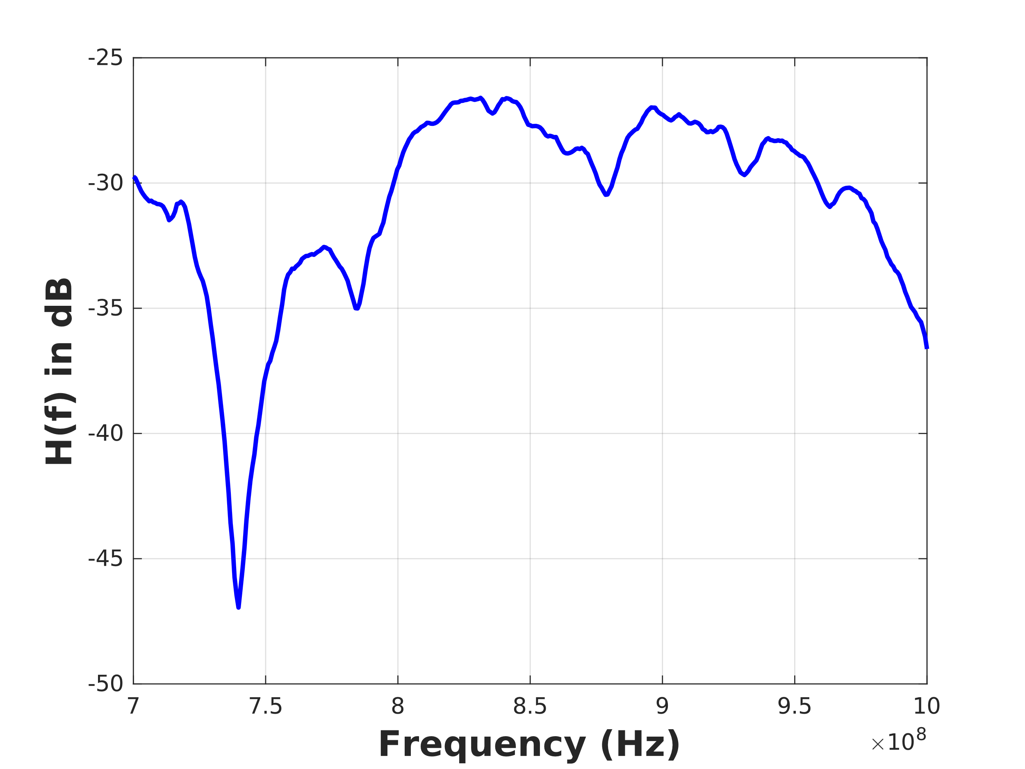
Figure 2: Frequency response of the channel for close distance

As we expected, we can see in figure.1 the impulse response includes one large peak around 5 ns and also we have received some small Peak after the main peak which have much smaller amplitude compared to main peak which are mostly due to the small reflections that we have in the environment in spite that the antennas are placed very close to each other.
Based on the frequency response shown in figure 2, the coherence bandwidth which is defined by the frequency range where the H(f) is somewhat flat and has little amplitude variation (around 3dB variation) is around one section of the plot which is around 50 megahertz. On the other hands, the analysis of the impulse response using the MATLAB code for close distance shows that:
Time_first_moment = 4.9645e-08 (sec)
Time_second_moment = 2.4843e-15 (sec)
Sigma = 4.4316e-09 (sec)
Coherence_BW = 4.5131e+07 (Hz)
The analysis result shows Coherence_BW = 45 MHz which is good agreement between the calculated coherence BW from impulse response and the observed BW from frequency response.
- Medium distance:
Using the MATLAB code and the provided data correspond to medium antenna position the impulse response and the frequency response of the channel are plotted in figure 3 and 4.

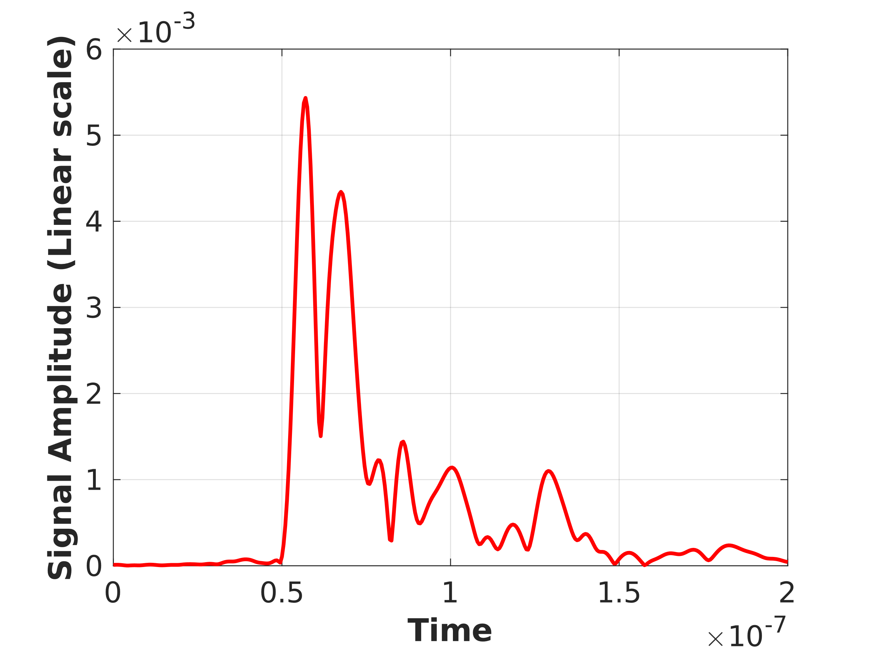
Figure 3: Impulse response of the channel for medium distance

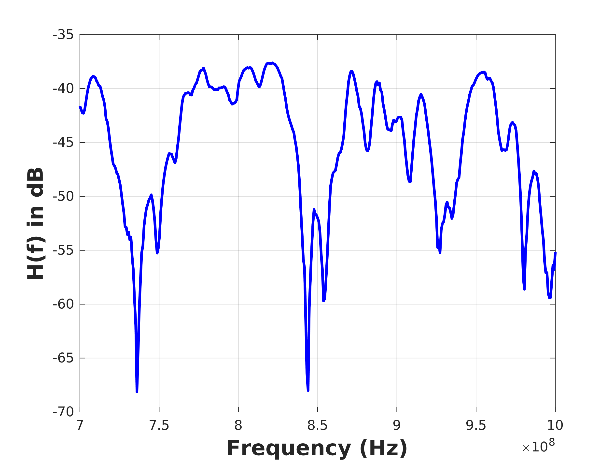
Figure 4: Frequency response of the channel for medium distance

As we expected, we can see in figure.3 the impulse response includes two larges peak after 5 ns and also we have received some small peak after the main two peaks which have smaller amplitude compared to main peak due to the reflections that we have in the environment. There are two things that we can also observe from amplitude impulse response of the channel in medium distance scenario. As we can see in the figure.3 the amplitude of receive signal is lower than the amplitude of the received signal in close distance experiment and also the delay is a little more than the first experiment due to the longer distance between two antennas.
Based on the frequency response shown in figure 4, we see several nulls in frequency response and the coherence bandwidth is around 1/5 of a time division of the plot which is around 10 megahertz. On the other hands, the analysis of the impulse response using the MATLAB code for close distance shows that:
Time_first_moment = 6.7079e-08 (sec)
Time_second_moment = 4.7697e-15 (sec)
Sigma = 1.6434e-08 (sec)
Coherence_BW = 1.2170e+07 (Hz)
Again, the analysis result shows Coherence_BW = 12 MHz which is good agreement between the calculated coherence BW from impulse response and the observed BW from frequency response.
- Far distance:
Using the MATLAB code and the provided data correspond to far antenna position the impulse response and the frequency response of the channel are plotted in figure 5 and 6.

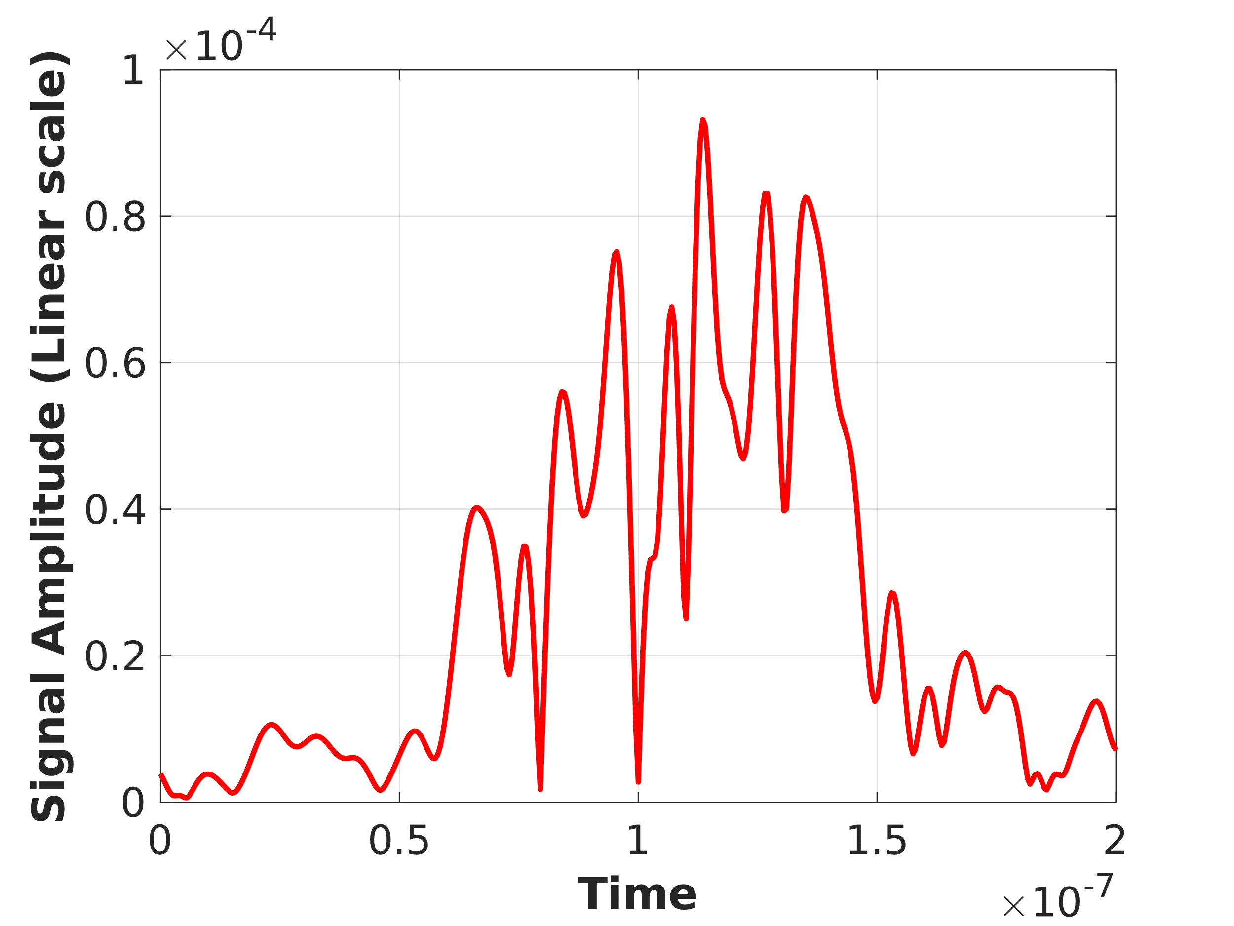
Figure 5: Impulse response of the channel for far distance

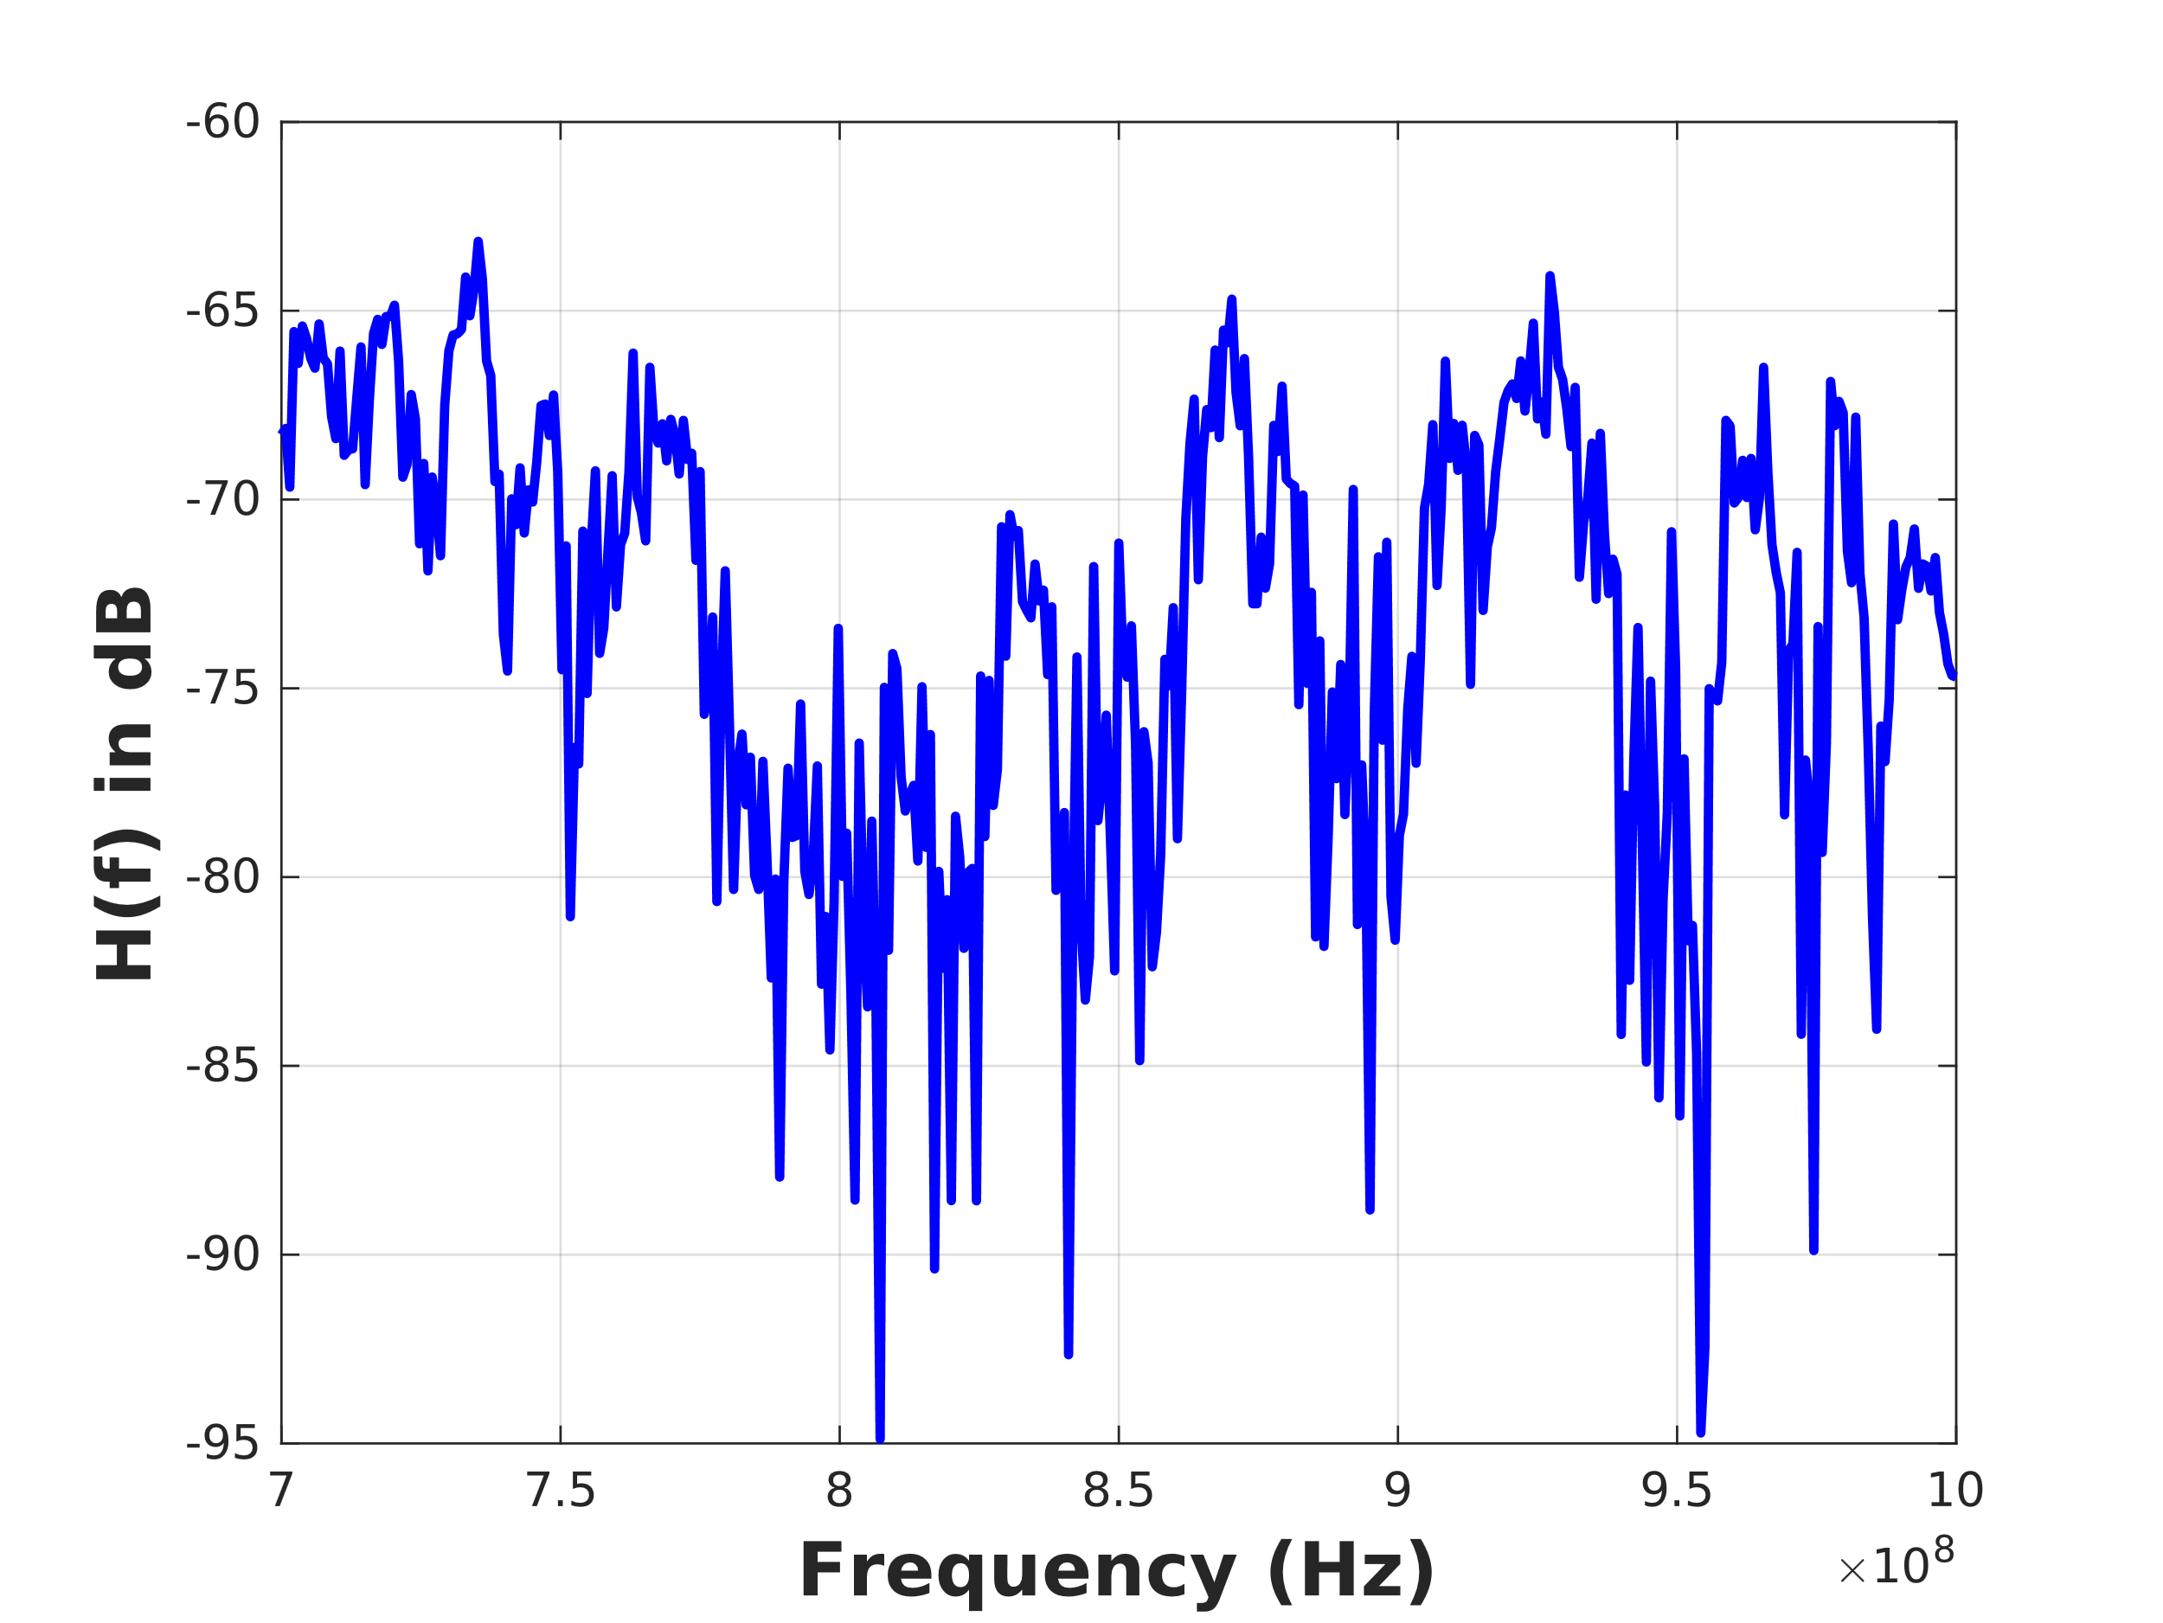
Figure 6: Frequency response of the channel for far distance

As seen in figure. 5 the impulse response includes several peaks randomly distributed in time due to multi-path presented in signal propagation environment. The impulse response peaks have much smaller amplitude compared to main peak in the close distance experiment and the maximum peak amplitude is not located at the first peak. As we can see in the figure.5 the time distribution of the impulse response covers wider time range which will cause sharper and faster frequency variation in frequency domain.
Based on the frequency response shown in figure 4, we see several nulls in frequency response and the coherence bandwidth is around 1/10 of a time division of the plot which is around 5 megahertz. On the other hands, the analysis of the impulse response using the MATLAB code for close distance shows that:
Time_first_moment = 1.1505e-07 (sec)
Time_second_moment = 1.3841e-14 (sec)
Sigma = 2.4605e-08 (sec)
Coherence_BW = 8.1286e+06 (Hz)
The analysis result shows Coherence_BW = 8.1 MHz which is somewhat good agreement between the calculated coherence BW from impulse response and the observed BW from frequency response.

Conclusion:
In this experiment we have seen the effect of multipath wireless communication environment. we saw that for short distance between transmitter antenna and receiver antenna and we have a line of sight usually the effect of multipath is less important while when we increase the distance between transmitter and receiver and especially when we don't have line-of-sight the effect of reflection and multipath are more dominant. As a result, we see wider spread of delay in impulse response in time domain and also very intense variation in frequency domain for far distance when several reflected signal received by the receiver, and also we have observed that the coherence bandwidth calculated based on the moment parameters and sigma of the delay in impulse response has a good agreement with the observed coherence bandwidth in frequency response in all cases although there are some difference between them which shows that maybe we need to use a correction factor in the equation between the BW and variance of the impulse response time.
Another important conclusion from this experiment is that when we increase distance between transmitter and receiver antennas the coherence bandwidth is reducing considerably which limits the communication BW. So the available BW with flat response for the application that there are far distance between transmitter and receiver is a critical challenge specially when high data rate and wide BW is required.

Appendix A.1
MATLAB Codes:

clear all
close all
clc
%++++++++++++++++++++++++++++++++++++++++++++++++++++
% Initialization of Parameter
%++++++++++++++++++++++++++++++++++++++++++++++++++++
load G2_close_time.txt
load G2_close_freq.txt
load G2_med_time.txt
load G2_med_freq.txt
load G2_far_time.txt
load G2_far_freq.txt

Signal_amp_time = G2_far_time(:,1)'; % Signal amplitude of recieved signal corrspond to the impulse Response of channel
Power_mag_freq_dB = G2_far_freq(:,1)'; % Signal magnetude in dB of recieved signal corrspond to the H(f) of channel

% % % Signal_amp_time = G2_med_time(:,1)'; % Signal amplitude of recieved signal corrspond to the impulse Response of channel
% % % Power_mag_freq_dB = G2_med_freq(:,1)'; % Signal magnetude in dB of recieved signal corrspond to the H(f) of channel
% % % Signal_amp_time = G2_far_time(:,1)'; % Signal amplitude of recieved signal corrspond to the impulse Response of channel
% % % Power_mag_freq_dB = G2_far_freq(:,1)'; % Signal magnetude in dB of recieved signal corrspond to the H(f) of channel

L_t = length(Signal_amp_time);
L_f = length(Power_mag_freq_dB);
Time = 0 : 0.5 : 0.5 * (L_t-1) ; % Time nsec
Time = Time * 1e-9; % Time sec
Freq = 700 : 0.75 : 700 + 0.75 * (L_f-1) ; % Frequency MHz
Freq = Freq * 1e6; % Frequency Hz
%++++++++++++++++++++++++++++++++++++++++++++++++++++
% Calculating Impulse Response moments
%++++++++++++++++++++++++++++++++++++++++++++++++++++
Time_first_moment = sum((Signal_amp_time.^2).*Time)/sum(Signal_amp_time.^2) % Calculating the average time of arrival <t>
Time_second_moment = sum((Signal_amp_time.^2).*(Time.^2))/sum(Signal_amp_time.^2) % Calculating the time spread of the multipath <t^2>
Sigma = sqrt(Time_second_moment - Time_first_moment^2) % Calculating the sigma
Coherence_BW = 1 / ( 5 * Sigma)
%++++++++++++++++++++++++++++++++++++++++++++++++++++++++++++++++++++++
% plotting the result
%++++++++++++++++++++++++++++++++++++++++++++++++++++++++++++++++++++++
figure(1)
plot(Time,Signal_amp_time,'-r','LineWidth',2)
xlabel('Time','fontweight','bold','fontsize',16);
ylabel('Signal Amplitude (Linear scale)','fontweight','bold','fontsize',16)
set(gca,'FontSize',15)
grid on
figure(2)
plot(Freq,Power_mag_freq_dB,'-b','LineWidth',2)
xlabel('Frequency (Hz)','fontweight','bold','fontsize',16);
ylabel('H(f) in dB','fontweight','bold','fontsize',16)
grid on

